Q) 5.1 Create an named pipe and show its existence in program and in the working directory.

Code:
#include<stdio.h>
#include<sys/types.h>
#include<sys/stat.h>
#include<unistd.h>
#include<fcntl.h>

int main()
{
int a;
a = mkfifo("/tmp/pipe12",0777);
if(a == 0)
{
printf("Created");
unlink("/tmp/pipe12");
}
else
{
printf("Not Created");
unlink("/tmp/pipe12");
}
return 0;
}

output:
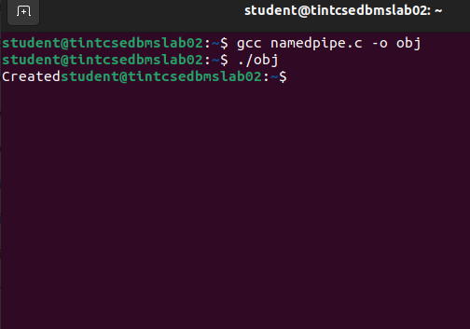

Q)5.2 Create an named pipe to communicate between 2 programs. Accept a string (user input ) in program1 and pass the string to program2 which will print it to verify the contents.

code:
prog1:

#include<stdio.h>
#include<sys/types.h>
#include<sys/stat.h>
#include<unistd.h>
#include<fcntl.h>

int main()
{
int a,f,w;
char str[20];
printf("Enter string: ");
fgets(str,20,stdin);
unlink("./pipe2");
a = mkfifo("./pipe2", 0777);
if(a == 0)
{
printf("pipe is created");
}
else
{
printf("pipe is not created");
}

f = open("./pipe2", O_WRONLY);
w = write(f,str, sizeof(str));
printf("No of bytes written %d", w);

return 0;
}

prog2:

#include<stdio.h>
#include<sys/types.h>
#include<sys/stat.h>
#include<unistd.h>
#include<fcntl.h>

int main()
{
int f,r;
char str1[20];
f = open("pipe2",O_RDONLY);
r = read(f,str1,sizeof(str1));

printf("%s", str1);

return 0;
}

output:

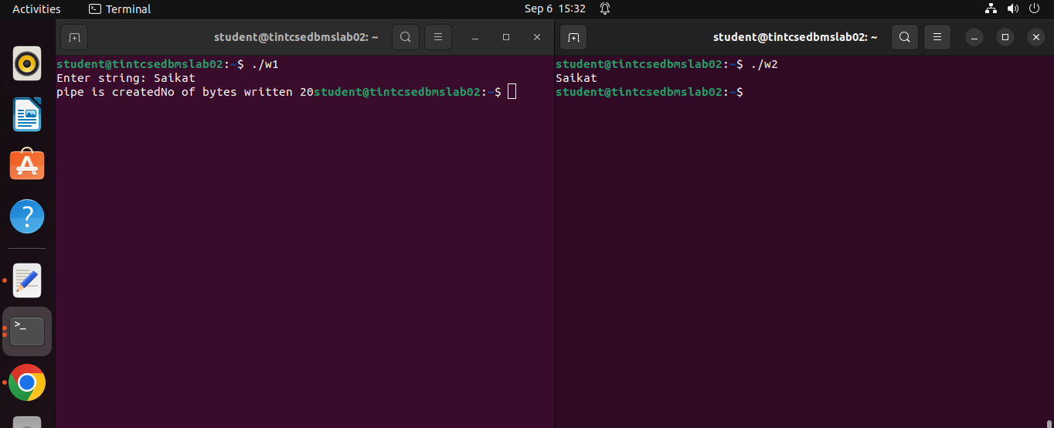

Q)5.3Use a named pipe (FIFO) to send an array of integers from a Program1 to Program2. The Program2, after receiving the array, will sort the array & send back to Program1. Program1 will print the sorted array.

code:

array1:
#include<stdio.h>
#include<sys/types.h>
#include<sys/stat.h>
#include<unistd.h>
#include<fcntl.h>

int main()
{
int f, b, w;
int arr[5], arr1[5];

unlink("pipe_2.1");

int a = mkfifo("pipe_2.1", 0777);

if(a == 0)
{
printf("Enter Array Elements :\n");

for(int i = 0; i<5; i++)
{
scanf("%d", &arr[i]);
}

f = open("pipe_2.1", O_WRONLY);
w = write(f, arr, sizeof(arr));
printf("Created\n");
sleep(2);
f = open("pipe_2.1", O_RDONLY);
b = read(f, arr1, sizeof(arr1));
printf("Sorted Array is :\n");
for(int i=0; i<5; i++)
{
printf("%d ", arr1[i]);
}
printf("\n");
}
else
{
printf("Not Created\n");
}

return 0;
}

array2:

#include<stdio.h>
#include<sys/types.h>
#include<sys/stat.h>
#include<unistd.h>
#include<fcntl.h>

int main()
{
int f, b, w;
int arr1[5];

f = open("pipe_2.1", O_RDONLY);
b = read(f, arr1, sizeof(arr1));
for(int i=0; i<5; i++)
{
for(int j=(i+1); j<5; j++)
{
if(arr1[i] < arr1[j])
{
int temp = arr1[i];
arr1[i] = arr1[j];
arr1[j] = temp;
}
}
}

f = open("pipe_2.1", O_WRONLY);
w = write(f, arr1, sizeof(arr1));
return 0;
}
output:

